
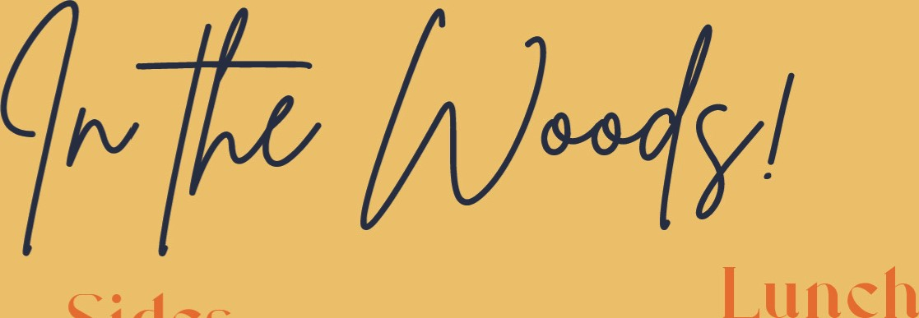
Breakfast Sides

Peanut butter Overnigh Oats E8.50 |  | Fries | 8.50
with bruleed bananas, Greek yogurt, elderflower curd + a caramelised white chocolate + sesame snap |  | Cajun seasoned fries | 24.50
Fodder Breakfast Bap Ell |  | Wild garlic butter fries | 24.95
Dexter sausage, bacon, black pudding, egg + smoky relish |  | Olives
Fluffy Pancakes E8.95  ADD |  | Halloumi | E4.50
Maple syrup, compote, Greek yogurt, bananas, Nutella El .50 each  Bacon, scrambled eggs, sausage 22.50 each |  | Hummus
Fodder Breakfast | El 3.95 | Fodder side salad - salad of the day | 25
Dexter sausage, bacon, black pudding, egg, tomato, potato bread, soda bread, bonfire beans, mushrooms |  | Fodder Slaw | 25
Fodder Meat Free Breakfast | El 2.50 | 
Halloumi, eggs, tomato, potato bread, soda bread, bonfire |  | Peppercorn sauce | 22
beans, mushroom + pesto |  | Honey + mustard mayo dip | El .50
 cd all (1m |  | Garlic mayo dip | El .50
Peanut Chilli Eggs | El 2.50 | Sriacha mayo dip | El .50
With satay chickpeas + seasonal veg. Wipe the bowl clean with a slice of sourdough. |  | Smoky tomato relish | El .50
Mushrooms on Sourdough | Ell | Seasonal pesto | El .50
Garlic butter mushrooms + pesto |  | Red onion marmalade | El .50
Served til 12pm
Add egg +21.50 bacon +22
Things on Toast POA Ask your senuer what today's is!

Sausage Roll E9.50
Either Dexter Beef or Vegan. Served with a side salad + homemade tomato relish Our Dexter Beef is all grass fed here at Finnebrogue Woods and can be bought from our farm shop next door!
Served from 12pm

Soup of the Day 27.95
Seasonal soup served with artisan bread
Add a Dexter beef bap for 26 Add pate for 23.50
Hummus Bowl (v) El 0.50
Pickles, nut crumb, cherry tomatoes + artisan bread
Fodder Dexter Burger & Fries El 6.95
Cheese, onions, lettuce, tomatoes, siracha mayo, gherkins + choice of skinny fries*
Fodder Hotdog & Fries
Cheese, tobacco onions, honey mustard mayo, smoky ketchup + choice of skinny fries*
The Ultimate Steak Sandwich 220.95
Medium rare Dexter prime steak, sauteed onions + mushrooms, horseradish, dulse seasoned fries + peppercorn sauce
Indian Pakora (v) Ell
With caramel siracha, lime coconut yogurt and a side salad.

Soul Bowl Ell

A bowl of the salad of the day, hummus, mixed leaves, and pickles.
Add Dexter roast beef +25. Add halloumi +23.95
The Woodland Picnic Board El 6.95
Scotch egg, salad of the day, Irish cheese, mushroom pate, sourdough, soup shot, medium rare Dexter roast beef + tomato relish(served cold - apart from the soup)

Please inform your server of any allergens!
www.finnebroguewoods.com



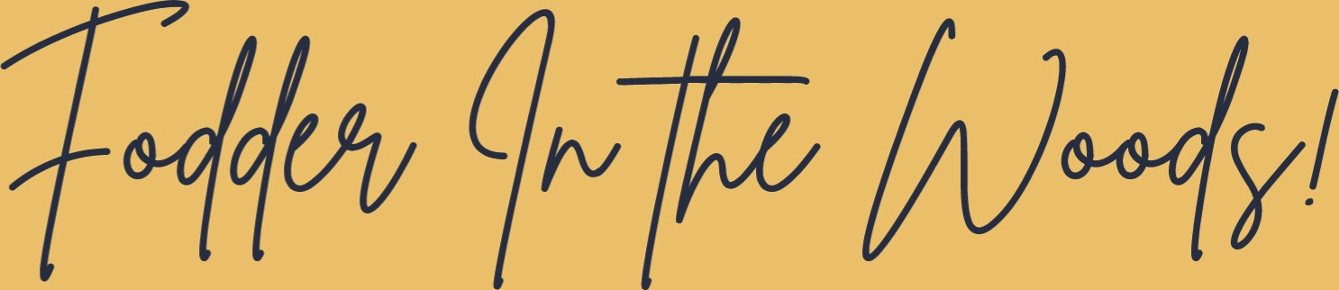

Cold drinks

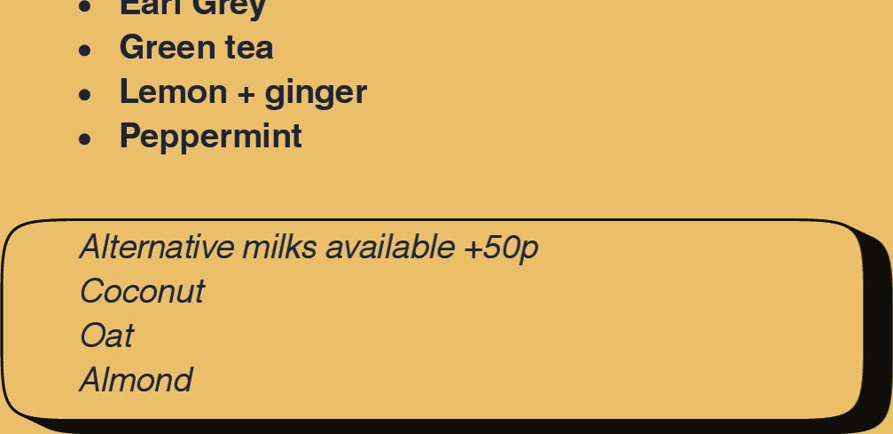
Under 14s only 22.95
Earl
Grey

San Pellegrino:
Espresso | 23.10 | Breakfast til 12
Americano | E3.10 | Cereal + Milk | 23.50 | Karma Cola/ Sugar Free Karma Cola | 22.95
Macchiato | 23.30 |  |  | Fentimans Ginger | 22.95
Cortado | 23.30 | Bacon sandwich + ketchup | 25.25 | Sparkling Rhubarb / Sparkling Pink lady apple | 23.20
Flat white | 23.40 | Pancakes | 25 | / sparkling rhubareb
Latte | 23.60 | Add: |  | Sparkling water / Still Water | El .95
Toasted mallow stick |  | Maple syrup El .50 |  | Fresh orange / apple juice
Cappuccino | 23.60 | Nutella El .50 |  |  | 22.50
Mocha | 24.20 | Bacon 22.50 |  | Kombucha | 23.95
IBC - Individually brewed coffee | 23.90 |  |  | Iced Latte | 23.70
Hot Chocolate w/ toasted marshmallows | 24.50 | Lunch Fronl IZpm |  | add syrup: caramel / coconut / vanilla
Kids hot chocolate w [toasted marshmallows | 23.50 | Hummus, cucumber sticks + soldiers | E4.50 | Lucky Saint 0.5% alcohol free beer | 24.75
Chai Latte | 23.60 | Sausage, beans + chips |  | Smoothies: | 24.50
 |  |  |  | Avo Go Go - mango, spinach, broccoli, avocado, coconut
Dirty Chai | 23.90 | Dexter burger + fries | Y .50 | Blueberry Thrill - blueberry, raspberry, banana, flaxseed Coco Loco - mango, coconut, pineapple
Selection of Tea available: | E2.90 | Dexter hotdog + fries | 25 | • Strawberry Split - strawberry + banana
Babbaccino | El .75
Happy Monkeys: | 22.25
Orange / lemon / pomegranate / blood orange

Treats
Toasted mallow stick
Strawberry + banana +

Apple blackcurrant
Glass of milk El .50

Please inform your server of any allergens! 

